Bilinear interpolation is an extension of linear interpolation for interpolating functions of two variables. The key idea is to perform linear interpolation first in one direction, and then in the other direction.
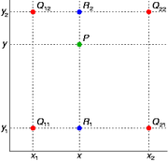

The four red dots show the data points and the green dot is the point at which we want to interpolate.
Suppose that we want to find the value of the unknown function f at the point P = (x, y). It is assumed that we know the value of f at the four points Q₁₁ = (x₁, y₁), Q₁₂ = (x₁, y₂), Q₂₁ = (x₂, y₁), and Q₂₂ = (x₂, y₂).
We first do linear interpolation in the x-direction. This yields
We proceed by interpolating in the y-direction.
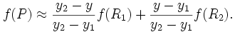
This gives us the desired estimate of f(x, y).
If we choose a coordinate system in which the four points where f is known are (0, 0), (0, 1), (1, 0), and (1, 1), then the interpolation formula simplifies to
Or equivalently, in matrix operations:
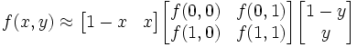
Contrary to what the name suggests, the interpolant is not linear. Instead, it is of the form
so it is a product of two linear function. Alternatively, the interpolant can be written as
In both cases, the number of constants (four) correspond to the number of data points where f is given.
The result of bilinear interpolation is independent of the order of interpolation. If we had first performed the linear interpolation in the y-direction and then in the x-direction, the resulting approximation would be the same.

Inverse distance
The simplest form of inverse distance weighted interpolation is sometimes called "Shepard's method" (Shepard 1968). The equation used is as follows:
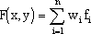
where n is the number of scatter points in the set, f_{i} are the prescribed function values at the scatter points (e.g. the data set values), and w_{i} are the weight functions assigned to each scatter point. The classical form of the weight function is:
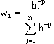
where p is an arbitrary positive real number called the weighting exponent and is defaulted to 2. The weighting expotent can be modified by turning on the Use classic weight function option. h_{i} is the distance from the scatter point to the interpolation point or
where (x,y) are the coordinates of the interpolation point and (x_{i},y_{i}) are the coordinates of each scatter point. The weight function varies from a value of unity at the scatter point to a value approaching zero as the distance from the scatter point increases. The weight functions are normalized so that the weights sum to unity.

